#Computer networks

Why?  
>>share data(docs, media, other information)  
  
  
#Network Bandwidth  
In computer networks, bandwidth is used as a synonym for data transfer rate, the amount of data that can be carried from one point to another in a given time period (usually a second).

#FACTORS affecting network performance  
>>bandwidth  
>>packet loss  
>>latency(delay)  
>>jitter(deviation from true periodicity)

#Major Different Communication Mediums

>>Copper wire  
>>Optical Fibre  
>>Wireless  
<http://smallbiztrends.com/2015/08/fiber-optic-copper-wireless-internet-transmission-methods.html>

>>satellites

#Types of Network

LAN  
>>for one building  
>>uses cables or wireless medium  
>>usually one of the devices act as a server  
  
MAN  
>>inter or intra cities  
>>use wireless medium, optical fibre

WAN  
>>connecting MANs  
>>use satellites, fibre optic cables  
>>egs The Inernet

#NODEs of a network  
>>Computer devices  
>>Servers  
>>Routers  
>>Modem  
>>Switches

+++Note- Host==Server. (People host parties and provide services to clients)

#NIC-Network Interface Card  
>>Helps to connect to any network  
>>Has two parts,   
 1. Port to connect to internet, Desktops usually connects via Ethernet cable, Laptops connects via wireless facility. Different NIC cards have different facilities for connection.   
 2. Internally connect to the motherboard.

++To know about your NIC card  
>>GO TO device manager  
>>Then Network Adaptor  
>> Realtek… is the inbuilt NIC card.

+++Note- You can also know about the specs of the PC in device manager.

#Protocols  
>>rules nodes should follow to have successful communication  
  
  
#The Open Systems Interconnection model (OSI model) is a conceptual model that explains the communication of a computing system without regard to their underlying internal structure and technology.

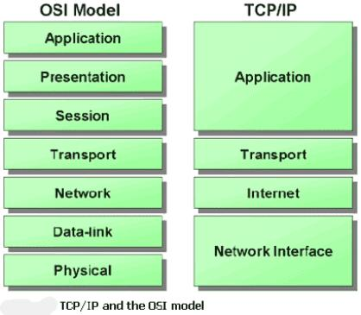

#modem  
>>Stands for Modulator-Demodulator  
>>Used to modify(modulate) the signals to be sent in a form which is easily transferable across the communication medium and demodulates once it reaches its destination back to the original signal.

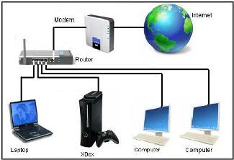

>>Devices sends their data, router decides the routes according to some algorithm, modem then modulates to a suitable form and then transmits further on cables.

#Routers  
>>decides best route to take from devices it is connected to the destination(maybe google’s servers)  
>>has 1 power point, 1 plug point for connecting modem, Few plug points for connecting devices, antennae(optional) to connect devices in wireless manner.

+++Note: wireless communication is   
>>not as fast as Ethernet cable transmission,   
>>can’t transmit to far distances without attenuation and   
>>even less secure…

#Switch  
>>Router has limited ports, thus switch provides a mechanism to connect multiple devices to the router as it has multiple ports.  
>>Switch has 1 port to connect to the router, and Few others to connect to the devices.  
  
  
QUESTION-Does distance from router(wifi signals) affects internet speed?  
>><http://superuser.com/questions/556874/does-distance-from-the-router-affect-internet-speed>

+++Repeater/Extender/amplifier boost the wifi signals. So the repeater is placed somewhere in between so that signals can reach at each and every part of the house.  
  
--------------------------------------------------------------------------------------------------------------------------------------

#IP address  
>>32 bits address used to identify each node uniquely.  
>>Its not only for PCs and mobiles, but also for routers, switches etc.   
  
#ISSUES with IP in INTERNET  
>>Internet is a network of network(say N1,N2,N3…) and   
>>count of these networks, summation(Ni) and devices in each of these network, N1 N2 N3 can vary drastically.  
>>THUS IP address of each device, in each network should be in such a way all the devices are covered in 32 bit addressing…  
>>ALSO it is important to divide the whole internet into components or subnets for the high efficiency of transmission because the packets received from the source device will be first sent to the destination network and then subsequently to the destination device. If the Internet is not divided into subnets the packet has to search the entire Internet for the destination IP.

#SOLUTION- having subnet mask  
>>Subnet mask is also a 32 bit number, in which first N bits are 1s and rest are 0s, which tells that first N bits of IP address is the network address and rest of 32-N bits are the device address in that particular network.

Example  
>>IP address is 108.161.228.70   
>>Subnet mask is 255.255.240.0  
Subnet mask 11111111 11111111 11110000 00000000  
IP address 01101100 10100001 1110XXXX XXXXXXXX

>>The part in RED will determine the Network IP  
Network IP 01101100 10100001 11100000 00000000  
Network IP is 108.161.224.0  
IP address is 108.161.228.70

+++NOTE 108.161.228.70 / 21 means that there are 21 “1s” in the subnet mask

Watch the rest of the videos, that is from video number 27 onwards!  
<https://www.youtube.com/playlist?list=PL6gx4Cwl9DGBpuvPW0aHa7mKdn_k9SPKO>

#QUESTIONS  
>>What is a WIFI?  
>>What is “stream a video”?  
>>(type of signal[analog or digital] might affect the choice of medium…CHECK IT?)  
>>specs of a server?  
>>How internet works in short?  
>>What is Ethernet, Ethernet cable?  
>>What is configuring a router and how to do it?